%{

%}

%%

"<"[^>]*> {**printf**("%s\n", yytext); }  /* if anything enclosed in

                                      these < > occur print text*/

. ;  // else do nothing

%%

**int** yywrap(){}

**int** main(**int** argc, **char**\*argv[])

{

    // Open tags.txt in read mode

**extern** **FILE** *yyin = **fopen**("tags.txt","r");

    // The function that starts the analysis

    yylex();

**return** 0;

}

%{

%}

%%

"<"[^>]*> {**printf**("%s\n", yytext); }  /* if anything enclosed in

                                      these < > occur print text*/

. ;  // else do nothing

%%

**int** yywrap(){}

**int** main(**int** argc, **char**\*argv[])

{

    // Open tags.txt in read mode

**extern** **FILE** *yyin = **fopen**("tags.txt","r");

    // The function that starts the analysis

    yylex();

**return** 0;

}

%{

%}

%%

"<"[^>]*> {**printf**("%s\n", yytext); }  /* if anything enclosed in

                                      these < > occur print text*/

. ;  // else do nothing

%%

**int** yywrap(){}

**int** main(**int** argc, **char**\*argv[])

{

    // Open tags.txt in read mode

**extern** **FILE** *yyin = **fopen**("tags.txt","r");

    // The function that starts the analysis

    yylex();

**return** 0;

}

**PRACTICAL-8**

**AIM : Implement following programs using LEX.**

**1.** **Write a Lex program to print out all numbers from the given file**.

%{

%}

%%

[0-9]* {printf("%s\n", yytext); }

. ; // else do nothing

%%

int yywrap(){}

int main(int argc, char*argv[])

{

// Open tags.txt in read mode

extern FILE *yyin = fopen("tags.txt","r");

// The function that starts the analysis

yylex();

return 0; }

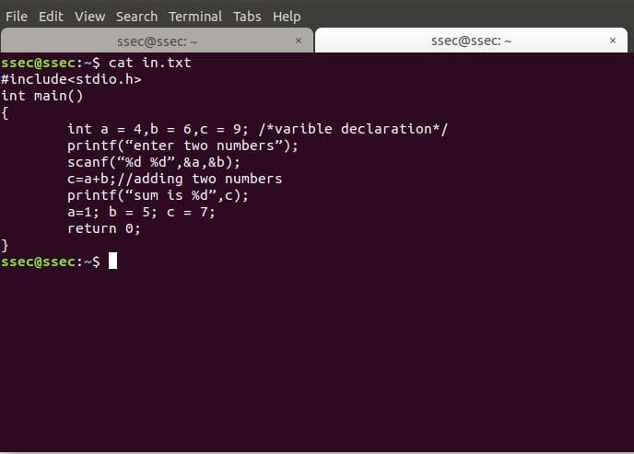

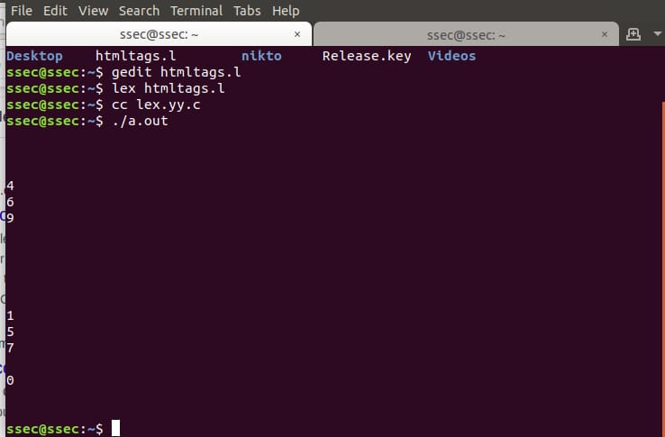

**2. Write a Lex program to printout all HTML tags in file.**

%{

%}

%%

"<"[^>]*> {printf("%s\n", yytext); } /* if anything enclosed in these < > occur print text*/

. ; // else do nothing

%%

int yywrap(){}

int main(int argc, char*argv[])

{

// Open tags.txt in read mode

extern FILE *yyin = fopen("tags.txt","r");

// The function that starts the analysis

yylex();

return 0; }

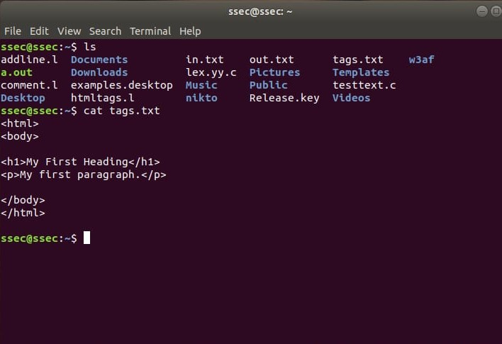

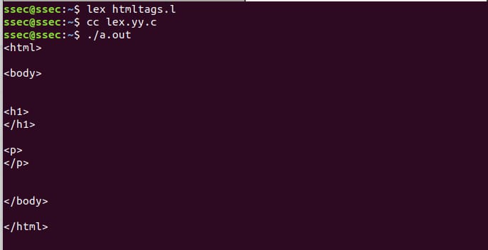

**3**. **Write a Lex program which adds line numbers to the given file and display the same onto the standard output.**

%{

int line_number = 1;  // initializing line number to 1

%}

%%

{line} { printf("%10d %s", line_number++, yytext); }

%%

int yywrap(){}

int main(int argc, char*argv[])

{

extern FILE *yyin;

yyin = fopen("testtest.c","r");

yylex();

  return 0;

}

